List of Contents

ABSTRACT 1

Chapter 1. Introduction to Energy Harvesting 2

1.1 Introduction 2

1.2 Piezoelectric Energy Harvesting 3

1.3 Electrostatic/capacitive Energy Harvesting 4

1.4 Magnetostrictive Energy Harvesting 5

1.5 Electromagnetic Energy harvesting 6

Chapter 2. Literature review 8

Chapter 3. Design and Development of Experimental Setup 10

3.1 Introduction 10

3.2 Selection of primary mass and primary spring rate 10

3.3 Primary Spring rate 11

3.4 Selection of motor 12

3.5 Design of shaft 14

3.6 Cam and Follower 14

3.7 Structural Frame 15

3.8 Bearing 15

3.9 Experimental Setup 17

Chapter 4. Basic Analytical Tools for the Design of Resonant Vibration Transducers. 18

4.2 Mechanical Subsystem 18

4.2.1 Linear Spring System 18

4.3 Electromagnetic Subsystem 21

4.3.1 Basics on Electromagnetic Induction 21

4.4 Overall System 23

4.4.1 General Behavior 23

Chapter 5. Selection of Magnet 26

5.1 Permanent Magnets 26

5.2 Temporary Magnets 28

5.3 Electromagnets 28

5.4 Magnetism 29

5.4.1 Diamagnetism 29

5.4.2 Paramagnetism 30

5.4.3 Ferromagnetism 31

Chapter 6. Design of Electromagnetic Coil 32

6.1 Coil no. 1 32

6.2 Coil no. 2 35

Chapter 9. Conclusion 40

Chapter 10. Future Work 42

Chapter 11. References 43

List of Figures

Figure 1.1 Piezoelectric 2

Figure 1.2 Electrostatic/capacitive Energy Harvesting 3

Figure 1.3 Magnetostrictive Energy Harvesting 4

Figure 1.4 Electromagnetic Energy harvesting 5

Figure 3.1 Primary spring 10

Figure 3.2 Schematic diagram of structural frame 13

Figure 3.3 Selection of bearing JBF and SKF catalog 14

Figure 3.4 SDOF system 15

Figure 4.1 Linear SDOF with harmonic base excitation and free body diagram 17

Figure 4.2 (a) and (b) shows plot of equation 2.9, (c) and (d) shows plot of equation 2.10 19

Figure 4.3 Popular models for linearized electromagnetic transducer analysis 20

Figure 4.4 Circuit diagram representation of electromagnetic subsystem for analytical analyses 21

Figure 4.5 Example of cylindrical air cored coil 22

Figure 4.6 Ratio of resistance Rcoil to reactance Xcoil in percent for different winding areas Aw of the example coil at at 100Hz 22

Figure 4.7 Block diagram of the overall transducer model for simulation in Matlab/Simulink 25

Figure 5.1 Types of magnets 29

Figure 5.2 Diamagnetism 31

Figure 5.3 Paramagnetism 31

Figure 7.1 Arduino UNO board 40

Figure 7.2 Arduino board description 41

Figure 7.3 Arduino Mega board 44

Figure 7.4 Working principle of Ultrasonic sensor 47

Figure 7.5 ultrasonic sensor 48

Figure 7.6 Comparing the Sensors reading with scale 49

Figure 7.7 proximity sensor 50

Figure 7.8 Principle of proximity sensor 51

Figure 7.9 Comparing the speed reading with the tachometer 54

Figure 7.10 Connection of sensors with Arduino 55

Figure 8.1 Number of readings vs Displacement plot at 183 rpm without coil mass 59

Figure 8.2 Frequency ratio v/s transmissibility without mass of coil 61

Figure 8.3 Frequency ratio v/s magnification factor without mass of coil 62

Figure 8.4 Frequency ratio v/s transmissibility with mass of coil 64

Figure 8.5 Frequency ratio v/s magnification factor with mass of coil 65

Figure 8.6 Frequency ratio v/s voltage graph 67

**List of Tables**

Table 1 Spring specifications 10

Table 2 For calculation of Total number of turns (N) Coil I 35

Table 3 For calculation of Inductance and Resistance of coil (Lcoil and Rcoil) Coil I 35

Table 4 For calculation of Total number of turns (N) Coil II 38

Table 5 For calculation of Inductance and Resistance of coil (Lcoil and Rcoil) Coil II 38

Table 6 Observation table for without coil 60

Table 7 Observation table for Coil I and 10 mm Magnet 63

Table 8 Observation table for voltage generated 66

Notations

= Longitudinal number of turns (turns)

= Lateral number of turns (turns)

N= Total number of turns (turns)

= Length of coil (mm)

= Inner radius of coil (mm)

= Outer radius of coil (mm)

= Inner diameter of coil (mm)

= Outer diameter of coil (mm)

= Wire diameter of coil (mm)

= Copper fill factor

= Coil resistance (ohms)

= Load resistance (ohms)

= Coil inductance (Henry)

= Resistance per meter of wire (ohms/m)

m= Mass (kg)

k= Stiffness of spring (N/m)

c= dashpot constant (N.s/m)

X= Absolute displacement of mass (mm)

Y= Amplitude of harmonic excitation (mm)

Z= Relative displacement (mm)

= Absolute velocity (m/s)

= Velocity of follower (m/s)

= Relative velocity (m/s)

= Acceleration of mass (m/s2)

= Acceleration of follower (m/s2)

= Relative acceleration (m/s2)

= Magnetic flux (Weber)

B= Magnetic flux density (Weber/m2)

l= Length of mean coil diameter (mm)

= Parasitic natural frequency (rad/s)

= Electromechanical natural frequency (rad/s)

λ , r= Frequency ratio

= Parasitic damping factor

= Electromechanical damping factor

= Magnification factor at resonance condition for parasitic system

= Magnification factor at resonance condition for electromechanical system

# ABSTRACT

# Now a day power generation is the main consideration to meet the future load demand. Magnetic shock absorber is equipped with electro-magnets/ permanent magnets of same polarity generate repulsive force which is used to absorb high frequency shock load. Two magnets are placed in upper and lower half of the magnetic shock absorber. The reciprocating rod is equipped with another magnet. This magnet will reciprocate up and down longitudinally. Thus movement of magnet and cylinder helps to generate small amount of electricity and that we are going to store in the battery and we can utilize this for various automobile applications

# In this project we have tried to develop test set up to do analysis of power generation with the help spring suspension.

# Chapter 1. Introduction to Energy Harvesting

## 1.1 Introduction

**Problem definition**

Electricity is something that people cannot live without in the modern day. Without it, life will be so much difficult and slow. The amount of resistance a shock absorber develops depends on the speed of the suspension and the number and size of the holes of the piston. All modern shock absorbers are velocity sensitive hydraulic damping devices. This means that the faster the suspension moves the more resistance the shock absorber provides.

Now a days the existing suspension system work for to reduce the vibrations and jerks received from road conditions, but during this process according to uneven road condition the compression and expansion of spring is occur and that movement of shock absorber is wasted. In this project we have tried to utilize this amplitude to generate the small amount of electricity.

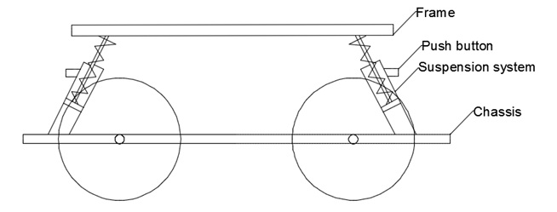

Energy harvesting is the process by which energy is derived from external source. There are ambient sources of energy available in the environment. E.g. Solar energy, wind energy, hydraulic energy, vibration energy etc. The problem statement is “The batteries are recharged or replaced” i.e. batteries are having limited life span thus they have to replace after some span. There are many equipment’s in our day to day life in which we are using the batteries. Thus our main approach from this project is able to extract this vibration energy which is going to waste and use for energy harvesting which is useful for human in day to day life. E.g. charging the mobiles, head lights and tail lights of automobile, indicators etc.

There are many researcher doing their research to minimize the vibration but vibrations cannot be diminished completely. Thus by using this undiminished vibration we can do the energy harvesting. The way to produce Harvesting energy from Vibration effect is explained in detail. There are many other ways to produce energy like solar, wind, temperature difference, piezoelectric material, water and vibration. In these ways by selecting Vibration energy harvesting can be effectively done.

The Vibration theory consists of three basic elements that is spring, inertia and damper. In some cases of mechanical elements, vibration means loss of energy, so by using elements of vibrations that is spring, inertia and damper, we can reduce vibration to some extent and remaining we can convert into an equivalent amount in other form of energy. In this project work we converted that wastage vibration energy into most needed electrical energy by using Energy Harvester. Basically there are two types of vibrations namely free vibration and forced vibration.

Free vibration occurs when a mechanical system is set off with an initial input and then allowed to vibrate freely. Forced vibrations are when a time-varying disturbance (load, displacement or velocity) is applied to a mechanical system. [1]

There are four methods of harvest the vibrational energy:

1. Electromagnetic Energy harvesting
2. Piezoelectric vibrational energy harvesting
3. Electrostatic/capacitive vibrational energy harvesting
4. Magnetostrictive vibrational energy harvesting.

## 1.2 Piezoelectric Energy Harvesting

[Piezoelectric](https://en.wikipedia.org/wiki/Piezoelectric) based generators use thin membranes or [cantilever beams](https://en.wikipedia.org/wiki/Cantilever) made of piezoelectric crystals as a transducer mechanism. When the crystal is put under [strain](https://en.wikipedia.org/wiki/Strain_(engineering)) by the kinetic energy of the vibration a small amount of current is produced thanks to the piezoelectric effect. These mechanisms are usually very simple with few moving parts, and they tend to have a very long service life. This makes them the most popular method of harvesting the energy from vibrations. These mechanisms can be manufactured using the [MEMS](https://en.wikipedia.org/wiki/Microelectromechanical_systems) fabrication process, which allows them to be created on a very small scale. The ability to make piezoelectric generators on such a small scale is the main advantage of this method over the electromagnetic generators, especially when the generator is being developed to power [microelectronic](https://en.wikipedia.org/wiki/Microelectronics) devices.



Figure 1.1 Piezoelectric

## 1.3 Electrostatic/capacitive Energy Harvesting

This type of harvesting is based on the changing capacitance of vibration-dependent capacitors. Vibrations separate the plates of a charged variable capacitor, and mechanical energy is converted into electrostatic energy. Electrostatic energy harvesters need a polarization source to work and to convert mechanical energy from vibrations into electricity. The polarization source should be in the order of some hundreds of volts; this greatly complicates the power management circuit. Another solution consists in using [electrodes](https://en.wikipedia.org/wiki/Electret) that are electrically charged dielectrics able to keep the polarization on the capacitor for years. It's possible to adapt structures from classical electrostatic induction generators, which also extract energy from variable capacitances, for this purpose. The resulting devices are self-biasing, and can directly charge batteries, or can produce exponentially growing voltages on storage capacitors, from which energy can be periodically extracted by DC/DC converters

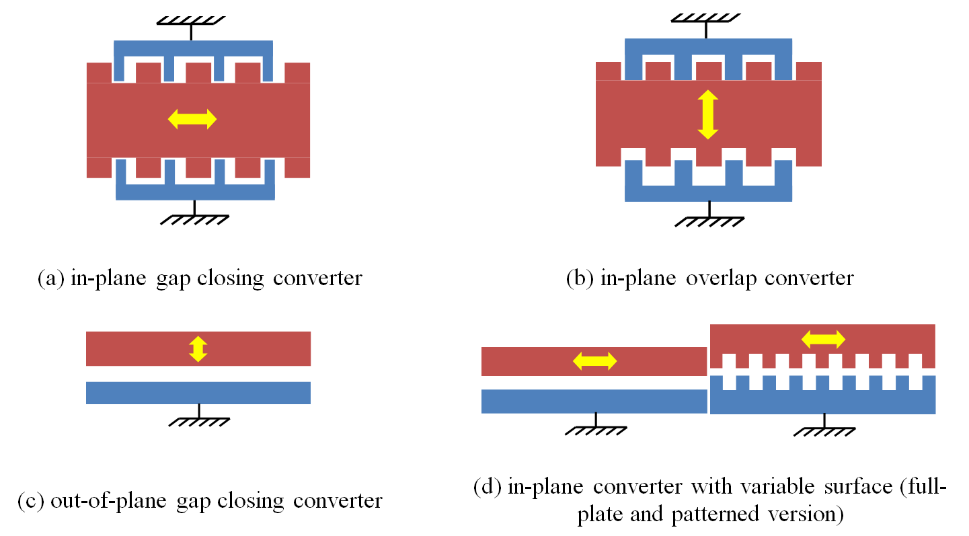

Figure 1.2 Electrostatic/capacitive Energy Harvesting

## 1.4 Magnetostrictive Energy Harvesting

Magnetostrictive material has been recently considered in applications of vibration energy harvesting. It utilizes Villari effect, where vibration induced strain of a Magnetostrictive material produces a change in the magnetization of the material. Upon dynamic or cyclic loading, this change in magnetization is converted into electrical energy using a pick-up coil or solenoid surrounding the Magnetostrictive layer according to Faraday’s law. Staley and Flatau (2005) attempted to apply a Terfenol-D alloy in vibration energy harvesting. The Terfenol-D rod was operated in axial mode rather than flexural bending mode. It had bulky dimension because of 1000-turn pick-up coil and 1500-turn DC actuation coil for generating bias magnetic field. The maximum output power was up to 45μW at resonant frequency of 45 Hz, and the amplitude of AC output voltage was less than 0.35 V which was inapplicable to voltage rectification. Although new developed giant Galfenol was tested in experiments, the output performance was not significantly enhanced and still unlikely to output any DC voltage



Figure 1.3 Magnetostrictive Energy Harvesting

## 1.5 Electromagnetic Energy harvesting

Electromagnetic based generators use [Faraday's law of induction](https://en.wikipedia.org/wiki/Faraday%27s_law_of_induction) to convert the kinetic energy of the vibrations into electrical energy. They consist of magnets attached to a flexible membrane or [cantilever beam](https://en.wikipedia.org/wiki/Cantilever) and a coil. The vibrations cause the distance between the magnet and coil to change, causing a change in [magnetic flux](https://en.wikipedia.org/wiki/Magnetic_flux) and resulting in an [electromagnetic force](https://en.wikipedia.org/wiki/Electromagnetic_force) being produced. Generally the coil is made using a [diamagnetic](https://en.wikipedia.org/wiki/Diamagnetism) material as these materials have weaker interactions with the magnet that would dampen the vibration. The main advantage of this type of generator is that it is able to produce more power than the piezoelectric generators.



Figure 1.4 Electromagnetic Energy harvesting

**Why Electromagnetic?**

* In Electromagnetic system no need of smart material and external source.
* Electrostatic needs external voltage source. Mechanical constraints needed for this.
* Piezoelectric material is brittle. It has poor coupling. In this material possibility of charge leakage. It has high output impedance.
* Magnetostrictive has non-linear effect. This needs bias magnet. This system is difficult to integrate with MEMS.

# Chapter 2. Literature review

***D. Spreemann & Y. Manoli*** [1]writes about the basic analytics theory behind most of the presented devices is commonly known in the energy harvesting society. It is based on well understood linear second-order spring-mass-damper system with base excitation. The theory has been modified and described in various ways even though the basic finding are more or less the same. In most of these cases it is rather difficult even impossible to use the results of the analytical modelling directly for the design process of application oriented developments.

***S P Beeby, M J Tudor and N M*** ***White*** [2] reviews the state of the art in vibration energy harvesting for wireless, self-powered microsystems. They presented the characteristic equations for inertial-based generators, along with the specific damping equations that relate to the three main transduction mechanisms employed to extract energy from the system. A review of existing piezoelectric, Electromagnetic and Electrostatic is presented. Electromagnetic generators presented in the literature and reviewed including large scale discrete devices and wafer-scale integrated versions. The coupling factor of each transduction mechanism is discussed and the respective devices are presented in the literature.

***Garry Berkovic and Ehud Shafir*** [3] review various noncontact optical sensing techniques that can be used to measure distances to objects and related parameters such as displacements, surface profiles, velocities and vibrations. Some techniques are discussed and compared with each other. The relationship between distance measurement and other parameters are mentioned. Optical techniques are the large variety of uses and applications are discussed.

***G. Benet, F. Blanes Et. al*** [4] describe the IR sensor based on the light intensity back scattered from objects and able to measure distances of up to 1 m. The errors in the distance measurements are analyzed and modeled by simplified expression which for modeling the sensor response as a function of distance and angle of incidence. The method to estimate the reflection coefficient has presented.

***Vidyadhar Kamble, et. al*** [5] implement the distance measurement system using the ultrasonic waves. By using pulse echo and phase measurement method the distance is measured. The constructional details of sensors are explained.

***Chang-Woo Song and Seung-Yop Lee et al***. [6] talked about recently, there has been increasing research on segmented robots to mimic the peristaltic or serpentine motions and soft bodies of segmented animals. The developments of the miniaturized segment robots or ambulatory micro-robots have been applied to medical endoscopes, rescue robots, hazardous environment exploration, and industrial inspection systems. The segmented or miniaturized robots can be classified according to actuation devices. In general, electromagnetic actuators have many advantages such as fast response, simple control law, and low manufacturing cost compared with the other actuators.

***Lin Jin , Albert Chee W. Lu, Lai L. Wai, Wei Fan et al.*** [7]presented about Insatiable demand for broadband wireless performance are driving the need for advanced circuits and systems. Key attributes include increased data rate, reduced power consumption and cost-effective manufacturability.

***Chao-Liang Chang , Uei-Ming Jow, Chao-Ta Huang et al.*** [8] said the micro-inductor is a key component in wireless power transmission micro modules. In this paper, an optimum design for the micro-inductor was studied and related MEMS fabrication techniques were also developed.

# Chapter 3. Design and Development of Experimental Setup

## 3.1 Introduction

In the proposed system we have used the cam and follower system to give oscillation motion to permanent magnet vertically.

In the proposed system we have used the compression spring.

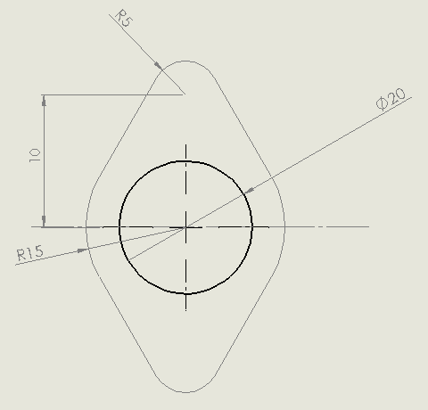

The total deflection of the spring is 15 mm

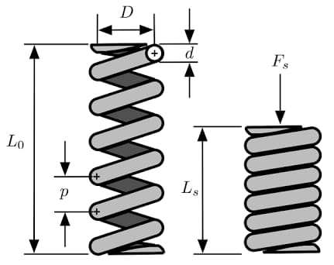

**Design of Main Spring**

The spring in between two magnets to avoid impact of magnets. The outer diameter can be selected considering the clearance between casing diameter and spring for avoid jam.

Outer diameter of spring, (Do) = 40 mm

For cold drawn wire steel,

Wire diameter d = 2.5 mm…… (Design data book)

Inner diameter of spring (Di) = 40-5

= 35 mm,

Calculating load bearing capacity of spring for service life,

Shear stress = 0.5× Sut = 0.5 ×1190

=595 N/mm2

Spring index, C= D0 /d

= 40/2.5

C = 16

Wahl’s correction factor for spring, Kw =

Kw = 1.088

Now find out load holding by spring K ,

Shear stress = Kw×

595 = 1.08 ×

P = 84.46N

Considering P =100N force.

Spring rate =

stiffness K = 7N/mm

Deflection of spring (δ) δ =

…G=82000

δ =

N = 0.9155mm

Minimum Number of turns N = 1 we have considered N = 10 turns

Number of Inactive turns = 2

Total number of turn, NT = N + 2

= 10 + 2

NT = 12

Solid length of spring, (Ls) = NT × d

= 12 x 5

= 60mm

Free length (Lf) = solid length + deflection + axial gap

Lf = 60 + 15 + 0.15(15)

Lf = 77.25mm

As per market availability we have considered total length = 100mm

**Selection of motor-**

Total load P= 100N.

The speed considered as per manufacturers requirement = N = 15rpm to 60rpm.

The cam max diameter on shaft = Dc = 50 mm

Rc = 50/2 = 25nmm

So Maximum Torque T = Effort x Radius

Total torque on shaft = 100 x 15 = 2500 N-mm

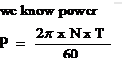

P = 2x 3.14 x60 x 2500 / (60x1000)

P = 15.7 watt

We are used here DC motor, in the market 40 watt DC wiper motor is available so we have used 40 watt DC motor.

**Design of shaft**

To design of shaft we have considered three loading conditions :-

* + 1. Against tortional moment
    2. Against bending moment
    3. Aganst both combining tortional and bending moment.
  1. **Design of shaft against tortional moment**

Total toque on screw shaft T = 2500 N-mm.

Material selection is a step in the process of designing any physical object. In the context of [product design](https://en.wikipedia.org/wiki/Product_design), the main goal of material selection is to minimize cost while meeting product performance goals. Systematic selection of the best material for a given application begins with [properties](https://en.wikipedia.org/wiki/List_of_materials_properties) and costs of candidate materials. Most of the times; failure arises due to improper selection of materials.

In design the material used for shaft we have to considered C40. The material selected for shaft is C40, as it is a popular grade.

##### Chemical composition %   of   steel   C40 (1.0511):   EN 10277-2-2008

|  |  |  |
| --- | --- | --- |
| **Grade** | **Min** | **Max** |
| Carbon (C) | 0.37 | 0.44% |
| Manganese (Mn) | 0.5 | 0.80% |
| Silicon (Si) | 0.38 | 0.4% |
| Nickel (Ni) | 0.38 | 0.4% |
| Molybdenum (Mo) | 0.9 | 0.1 |
| Chromium (Cr) | 0.38 | 0.4% |
| Phosphorous(P) | 0.42 | 0.45% |

Ordinary transmission shafts are made of medium with carbon content ranging from 0.15 to 0.40% such as 30C8 or 40C8. These steels are commonly called as machinery steels. For shaft design, 40C8 is used [***Machine design Data Book by V. B. Bhandari, McGraw Hill Education (India) Private Limited, pp. 2.13***]. Sut = 630N/mm2, Syt = 350N/mm2,

T = Max Torque generated to rotating drive shaft.

**As per ASME code**

The permissible shear stress without keyways is taken as 30% of yield strength in tension or 18% of the ultimate tensile strength of the material whichever is minimum. Therefore,

As the keyways are present, the above values are to be reduced by 25%.

Max torsion moment equation is given by

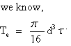

Where T = 2500N-mm

By using above equation drive shaft dia d = 5.66mm ……………….A

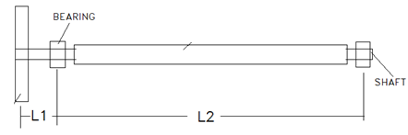

As per manufacturers data and roller length the L1 and L2 is considered

L1 = 50 mm

L2 = 300mm

**Maximum bending moment acting on the input shaft**

300mm

Free Body Diagram

*C*

Bending Moment Diagram

50mm

From eq (a) the tension due to belt is = P= RA + RB

L1 = 50 mm

L2 = 300mm

From eq (a) the tension due to belt is = P=100N

100 N

Taking moment about moment A,

Maximum bending moment,

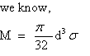

As per considering the application the spray procedure is non contacting type so considering factor of safety = 3

Ϭ = 210 N/ mm2 considering factor of safety = 3

By using above equation drive shaft dia d = 8.06 mm ………………..B

From equation A and B we have selected the diameter of shaft = 20mm at middle. Hence diameter of Shaft is selected 20mm

**According to maximum shear stress theory**

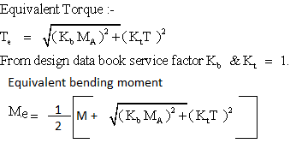

Te = 14985 N-mm

Me = 14880N-mm

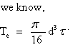

ځ = 9.54 < 74 N/mm2 and

Ϭ = 18.95 < 210 N/mm2

By using above equation we have checked the allowable shear stress and allowable bending stress and it is seen that the both values are within limit hence design is safe.

* 1. **Selection of bearing :-**

## *Bearing selection*

Axial load is negligible. Hence deep groove ball bearings are suitable for this type of gear box.

### Bearings for Mounted shaft

Designed the proposed machine is supposed to be used for eight hours per day. Therefore, the life of the bearing is taken as 15000 hours. Therefore,

**Equivalent dynamic load (P)**

The bearing is subjected to pure radial load Fr (Reaction at A). therefore,

The life of the bearing in million revolutions is calculated as below:

Therefore, dynamic load capacity,

p - 3 for ball bearing

|  |  |  |
| --- | --- | --- |
| **Sr. No.** | **Location** | **Designation** |
| 1 | drive shaft | 61804 |

**Referred from page no 326 SKF catalogue Single row deep groove ball bearings**



## 6.1 Coil no. 1

**Assumptions**-

* + The length of coil wire is 30 m, from standard wire gauge conversions our length of wire falls between 28 gauge to 32 gauge, we selected 29 gauge with 0.2859 mm wire diameter. This data is taken from Pyromation inc chart.
  + From magnet diameters 10 and 12 mm, we decided inner diameter of coil as 21 mm and outer diameter of coil as 38 mm. From consideration of total magnet height, we selected length of as 40 mm.
  + The copper fill factor is taken as 0.6 from electromagnetic energy harvesting journal.

**Observation:**

* + Coil inner radius() = 10.5 mm
  + Coil outer radius() = 19 mm
  + Length of coil() = 40 mm
  + Resistance per meter() = 0.5488 Ohm/m
  + Wire diameter() = 0.285 mm
  + Copper fill factor (Kco) =0.6 is taken from chapter no. 2 Electromagnetic Energy Harvesting of Springer Edition.

**Calculations:**

**Step 1-** Calculation of Longitudinal number of turns (Nlong)

**Nlong**

**Step 2-** Calculation of Lateral number of turns (Nlat)

**Nlat**

**Step 3-** Calculation of Total number of turns (N)

**N**

**Step 4-** Calculation of Inductance of coil (Lcoil)

**Lcoil**

**Step 5**- Calculation of Resistance of coil (Rcoil)

**Rcoil**

**Step 6**- Calculation of Parasitic viscous damping factor ()

**Step 7**- Calculation of electromechanical viscous damping factor (

Where, = Total viscous damping factor.

**Result Table**

**Table 2 For calculation of Total number of turns (N) Coil I**

|  |  |  |  |  |  |  |  |
| --- | --- | --- | --- | --- | --- | --- | --- |
| Sr.No. | Inner radius of coil (ri) in mm | Outer radius of coil (ro) in mm | Mean radius of coil  (rm) in mm  rm=(1/2).(ri+ro) | Length of coil (hcoil) in mm | Longitudinal number of turns (Nlong) in turns | Lateral number of turns (Nlat) in turns | Total number of turns (N) in turns  N=Nlong.Nlat |
| 1. | 10.5 | 19 | 14.75 | 40 | 122.6721 | 26.0678 | 3197.7945 |

From the result TABLE NO. 2 we got Total number of turns (N) as **3197.7945 turns**.

**Table 3 For calculation of Inductance and Resistance of coil (Lcoil and Rcoil) Coil I**

|  |  |  |  |  |
| --- | --- | --- | --- | --- |
| Sr.No. | Mean coil radius (rm) in mm | Length of coil (hcoil) in mm | Inductance of coil (Lcoil) in Henry | Resistance of coil (Rcoil) in Ohms |
| 1 | 14.75 | 40 | 0.131325 | 46.86336 |

From the result TABLE NO. 3. We got Inductance of coil (Lcoil)and Resistance of coil (Rcoil ) as **0.131325 Henry** and **46.86336 Ohms**.

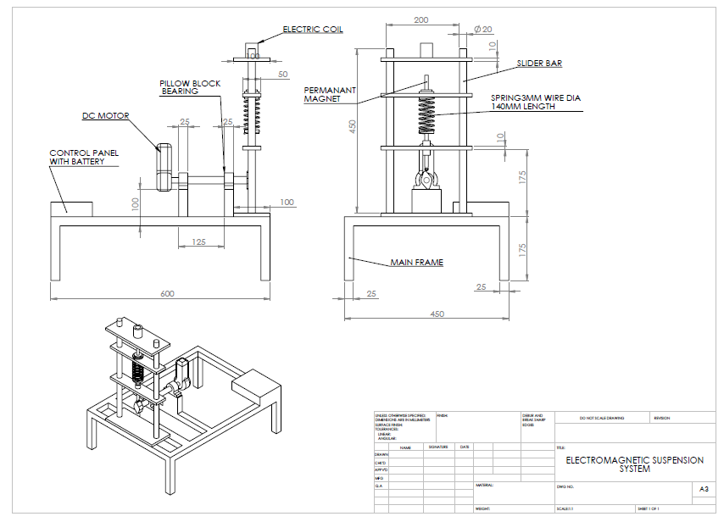

## 3.9 Experimental Setup

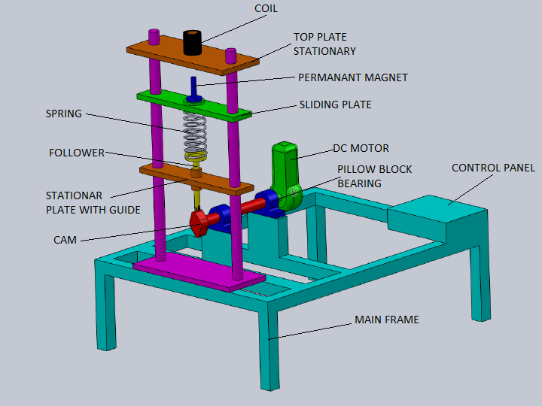

Figure 3.4 SDOF system

Figure 3.4 shows the entire SDOF system and its components in general. The drive motor when operated will develop the system output *x1(t)* for a system input *x0(t).*

# Chapter 4. Basic Analytical Tools for the Design of Resonant Vibration Transducers.

The presented review of existing work on electromagnetic inertial vibration transducers shows that there has been much interest in the design of vibration energy harvesting devices. Consequently excellent work has been done by numerous research facilities and a multiplicity of micro and centimeter scale prototype vibration transducers has been developed. The basic analytical theory behind most of the presented devices is commonly known in the energy harvesting society. It is based on a well understood linear second–order spring–mass–damper system with base excitation. Since then the theory has been modified and described in various ways even though the basic findings are more or less the same. In this respect, an analytical expression for the maximum output power that can be extracted from a certain vibration was derived and the optimization of parameters such as the optimal load resistance or the electromagnetic damping factor was discussed. However, as will be shown, in most of these cases it is rather difficult even impossible to use the results of the analytical modelling directly for the design process of application oriented developments. This is because the theory does not consider geometrical parameters and is based on simplifying assumptions which often do not correlate well with the “real world” (e.g. random vibration instead of harmonic excitation, complex load circuit instead of simple resistance or appreciable magnetic flux leakage instead of homogeneous magnetic field distribution). However the analytical modelling is useful for understanding the influence of the most important system parameters. Furthermore it offers a deeper insight into the overall system behavior. [1]

## 4.2 Mechanical Subsystem

### 4.2.1 Linear Spring System

The aim of a vibration transducer is the conversion of vibration energy into electrical energy. However energy from vibration can only be extracted by damping the vibration which is a common task in engineering to protect objects from failure. Thus from the theoretical point of view the theory of developing vibration transducers is similar to the development of passive vibration isolators. However for vibration transducers it is assumed that the energy conversion as well as the mass of the transducer has no effect on the vibration source. This assumption is fulfilled as long as the mass of the transducer is much smaller than the mass of the vibration source. A commonly used linear single degree of freedom mechanical model of a vibration transducer is shown in Fig 4.1. It consists of a mass *m* attached to a spring with spring rate *k* and a damping element with damping factor *d*. The governing equation of its motion *x*(*t*) is:

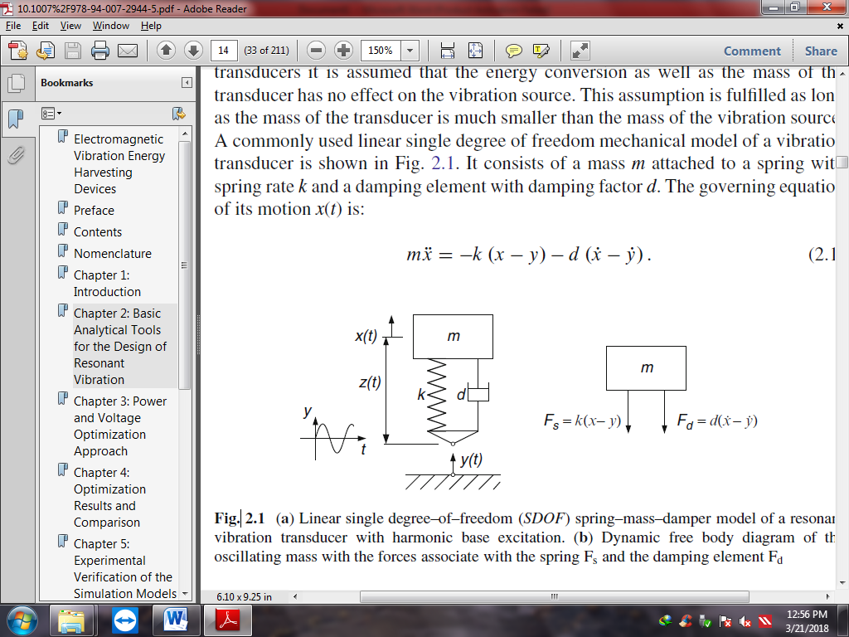

Figure 4.1 Linear SDOF with harmonic base excitation and free body diagram

For relative coordinates:

The equation becomes:

The excitation y(t) is assumed to be a harmonic function with the amplitude Y. The theory of this second order differential equation is well known. For this reason only the results which are important for the understanding of the system are discussed here. The solution to Eq. 2.3 can easily be found in the frequency domain with the Laplace transformation:

Rearranging yields the transfer function:

With the natural frequency of the undamped oscillation, the normalized damping factor and substituting the transfer function becomes:

In a ﬁnal step this transfer function can be written as a function of two variables by introducing the frequency ratio :

This solution can be applied if the excitation is a harmonic function. However since the Laplace equation is linear the sum of several individual solutions is also a solution. In other words, if the excitation is not a harmonic function the solution can be applied as long as the excitation function can be represent as a Fourier series of harmonic functions. This is a great advantage of the frequency domain analysis. For the steady state solution of Eq. 2.3 in time domain the particular integral has to be solved. The solution can be assumed to be of the form:

Where, Z is the amplitude of the relative oscillation and ' the phase between the excitation and the oscillation of the mass. By substituting Eq. 2.8 into Eq. 2.3 the amplitude and phase of steady state motion can be found to be:

For the absolute motion x the steady–state amplitude and phase are (solution of Eq. 2.1):

The curves are plotted in Figure 4.2. In spite of the relative motion, the natural frequency of the absolute motion decreases with increasing damping. The natural frequency of a damped oscillation can be calculated as follows:

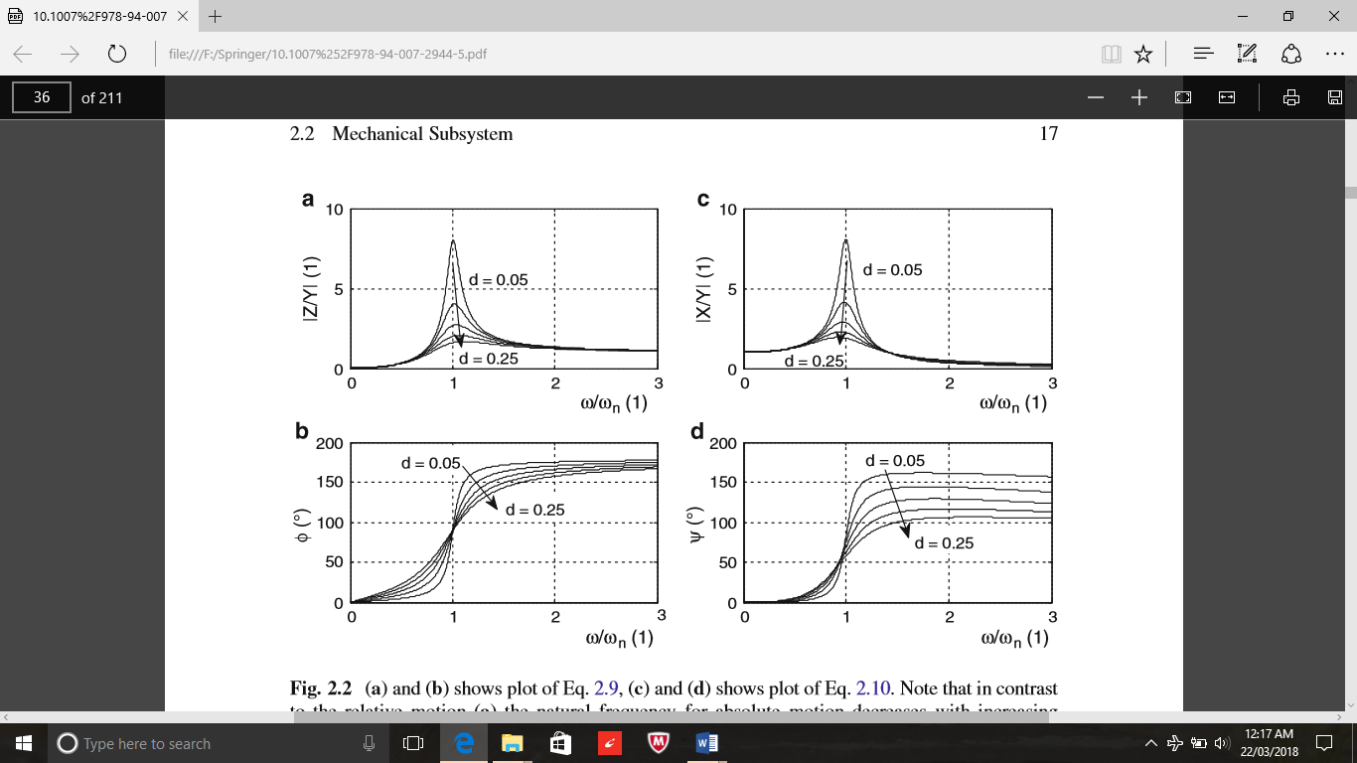

Figure 4.2 (a) and (b) shows plot of equation 2.9, (c) and (d) shows plot of equation 2.10

## 4.3 Electromagnetic Subsystem

### 4.3.1 Basics on Electromagnetic Induction

The output power of electromagnetic vibration transducers is related to the particular design of the electromagnetic coupling. Hence factors like size, material properties and geometric conﬁguration of magnet, coil and magnetic circuit play a vital key role in the design process. So far conclusions from literature are often based on very simplifying assumptions. This is because the analytical calculation of the magnetic ﬁeld is rather complicated for ironless systems and even impossible for systems with back iron. Nevertheless the basic theory of magnetic induction is necessary in order to understand how the electrical energy can be extracted. In electromagnetic vibration transducers the transduction mechanism is based on Faraday’s law of induction. This law states that any change of magnetic ﬂux through a conductive loop of wire will cause a voltage to be induced in that loop. The magnetic ﬂux is deﬁned as:

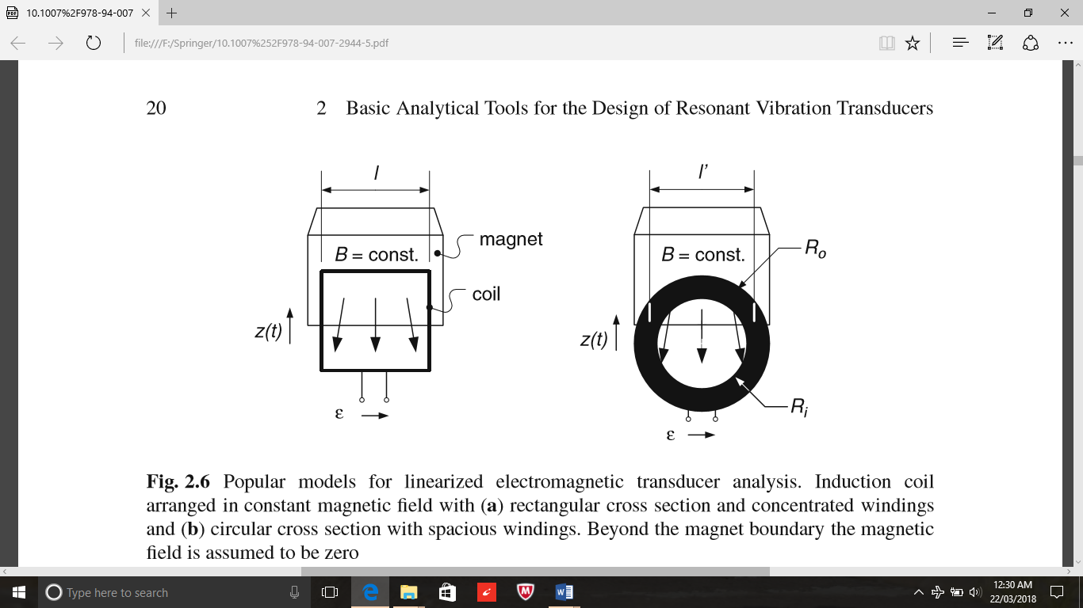

Figure 4.3 Popular models for linearized electromagnetic transducer analysis

Loop of wire will cause a voltage to be induced in that loop. The magnetic ﬂux is deﬁned as:

Where, A indicates the area enclosed by the wire loop and B is the magnetic ﬂux density. The induced voltage is the so–called electromotive force (emf) which is given by:

If one substitutes the magnetic ﬂux from Eq. 2.14, then the induced voltage becomes:

From this equation it is evident that for electromagnetic induction it does not matter whether the magnetic ﬁeld is changing within a constant area or the area is changing with in a constant magnetic ﬁeld. This characteristic offers a wide range of possible implementations of the electromagnetic coupling. Two basic arrangements are shown in Figure4.3. The coil in Figure4.3a has a rectangular cross section with concentrated windings whereas the coil in Figure4.3b has a circular cross section and the windings are spacious (more realistic case). For coils with N windings and rectangular cross section the change of overlapping area follows N.dA/dt = Nldz/dt = Nlz. Thus the emf voltage becomes.

Where, Kt is the transduction factor. The transduction factor equals the magnetic ﬂux gradient and is assumed to be constant in the analytical treatment.

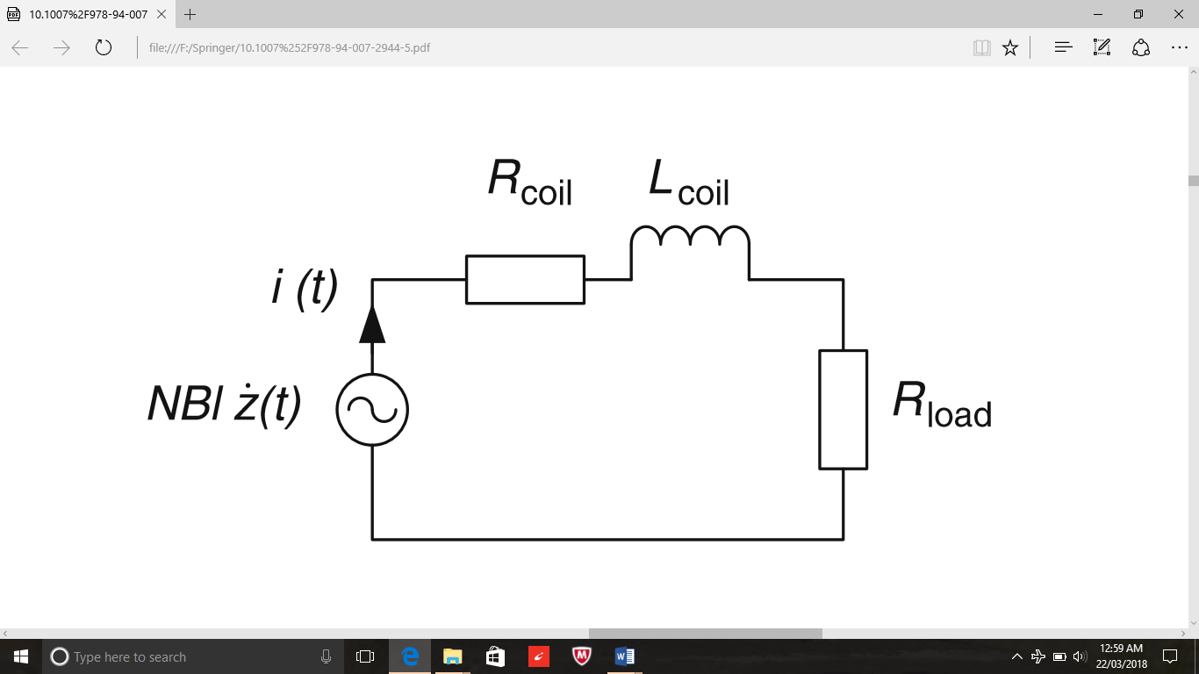

Figure 4.4 Circuit diagram representation of electromagnetic subsystem for analytical analyses

## 4.4 Overall System

### 4.4.1 General Behavior

The previous sections discussed the mechanical and electromagnetic subsystem of vibration transducers. These subsystems can now be combined to an overall system model. The mechanical domain (input force and relative velocity of the mass) and the electromagnetic domain (*emf* and induced current) are related via the transduction factor *k*t. For closed circuit condition the *emf* voltage will cause a current to flow. This current creates a magnetic field which opposes the cause according to Lenz’s law. The feedback electromechanical force is given by:

From Ohms law,

Hence the dissipative feedback electromechanical force due to the transducer can be represented by a velocity proportional viscous damping element with the damping coefficient:

Now the transfer functions of the subsystems (2.5) and (2.20) can be combined to an overall input force to output voltage transfer function for the electrodynamics transducer:

Where, the displacement of vibration has been replaced by the forcing function.

If the inductance is neglected then,

A block diagram of the underlying simulation model implemented in Matlab/Simulink® is shown in Figure4.7.

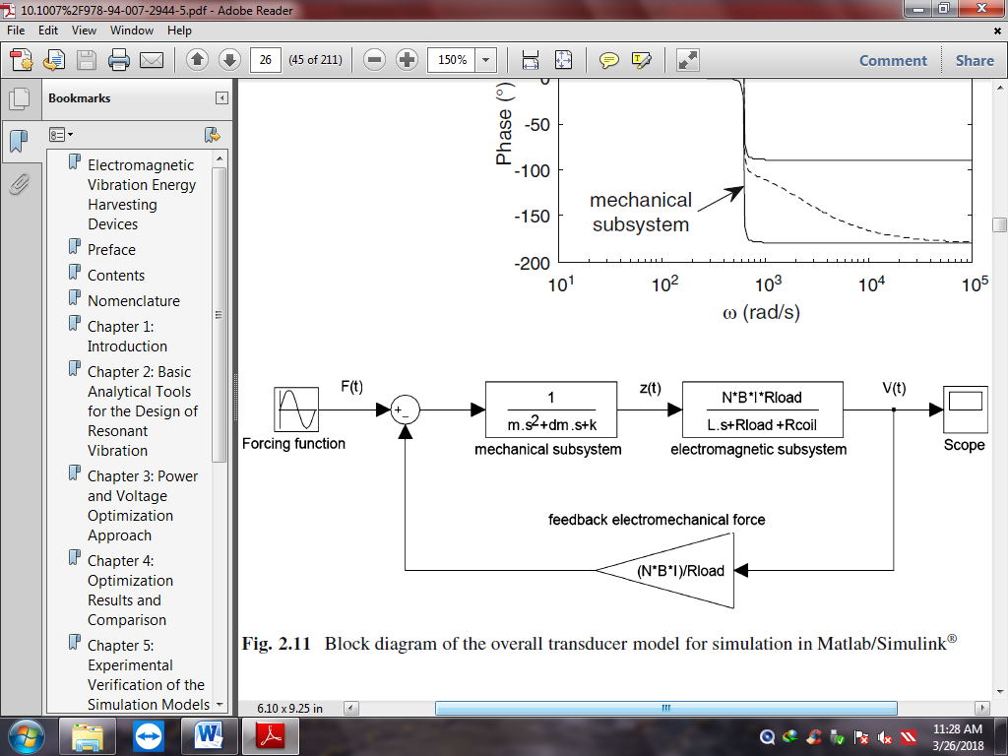

Figure 4.7 Block diagram of the overall transducer model for simulation in Matlab/Simulink

The instantaneous dissipated power (together with ) becomes:

The velocity is obtained by the first derivative of the steady state amplitude of (2.9):

Where the normalized damping factor has been split into the electromechanical and parasitic part () Substituting this equation into (2.33) the generated electrical power becomes:

For operation at resonance above equation can be reduced to:

Since the base excitation is a pure harmonic input of the form,

The output power may also be expressed as a function of the input acceleration amplitude:

From above equation optimum power can be calculated. [1,2]

# Chapter 5. Selection of Magnet

Magnets are objects that generate a magnetic field, a force-field that either pulls or repels certain materials, such as nickel and iron. Of course, not all magnets are composed of the same elements, and thus can be broken down into categories based on their composition and source of magnetism. Permanent magnets are magnets retain their magnetism once magnetized. Temporary magnets are materials magnets that perform like permanent magnets when in the presence of a magnetic field, but lose magnetism when not in a magnetic field. Electromagnets are wound coils of wire that function as magnets when an electrical current is passed through. By adjusting the strength and direction of the current, the strength of the magnet is also altered.

Neodymium is a metal which is ferromagnetic (more specifically it shows antiferromagnetic properties) meaning that like iron it can be magnetized to become a magnet, but its Curie temperature (the temperature above which its ferromagnetism disappears) is 19K(-2540C), so in pure form its magnetism on appears at extremely low temperatures. However, compounds of neodymium with transition metals such as iron can have Curie temperatures well above room temperature, and these are used to make neodymium magnets. Because of such properties we selected Ni-Fe-B as our magnet for energy harvester.

## 5.1 Permanent Magnets

There are typically four categories of permanent magnets: neodymium iron boron (NdFeB), samarium cobalt (SmCo), alnico, and ceramic or ferrite magnets.

* ***Neodymium Iron Boron (NdFeB)***

This type of magnet is composed of rare earth magnetic material, and has a high coercive force. They have an extremely high energy product range, up to 50 MGOe. Because of this high product energy level, they can usually be manufactured to be small and compact in size. However, NdFeB magnets have low mechanical strength, tend to be brittle, and low corrosion-resistance if left uncoated. If treated with gold, iron, or nickel plating, they can be used in many applications. They are very strong magnets and are difficult to demagnetize.

* ***Samarium Cobalt (SmCo)***

Like NdFeB magnets, SmCo magnets are also very strong and difficult to demagnetize. They are also highly oxidation-resistant and temperature resistant, withstanding temperatures up to 300 degrees Celsius. Two different groups of SmCo magnets exist, divided based on their product energy range. The first series (Sm1Co5) has an energy product range of 15-22 MGOe. The second series (Sm2Co17) has a range that falls between 22 and 30 MGOe. However, they can be expensive and have low-mechanical strength.

* ***Alnico***

Alnico magnets get their name from the first two letters of each of three main ingredients: aluminum, nickel, and cobalt. Although they feature good temperature resistance, they can easily be demagnetized and are sometimes replaced by ceramic and rare earth magnets in certain applications. They can be produced by either sintering or casting, with each process yielding different magnet characteristics. Sintering produces enhanced mechanical traits. Casting results in higher energy products and enables the magnets to achieve more complicated design features.

* ***Ceramic or Ferrite***

Comprised of sintered iron oxide and barium or strontium carbonate, ceramic (or ferrite) magnets are typically inexpensive and easily produced, either through sintering or pressing. However, because these magnets tend to be brittle, they require grinding using a diamond wheel. They are one of the most commonly used types of magnet, and are strong and is not easy to demagnetize.

## 5.2 Temporary Magnets

Temporary magnets can vary in composition, as they are essentially any material that behaves like a permanent magnet when in the presence of a magnetic field. Soft iron devices, such as paper clips, are often temporary magnets.

## 5.3 Electromagnets

Electromagnets are made by winding a wire into multiple loops around a core material—this formation is known as a solenoid. To magnetize electromagnets, an electrical current is passed through the solenoid to create a magnetic field. The field is strongest on the inside of the coil, and the strength of the field is proportionate to the number of loops and the strength of the current.

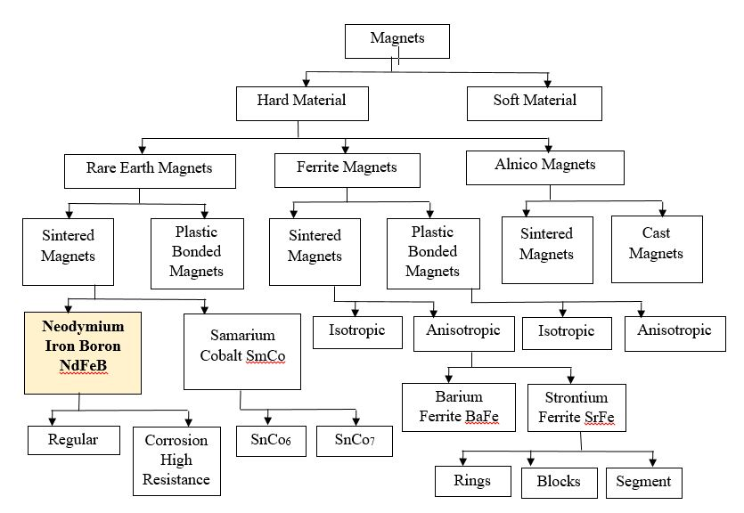

Figure 5.1 Types of magnets

The material at the center of the coil, the core of the solenoid, can also affect the strength of an electromagnet. If a wire is wrapped around a nonmagnetic material, such as a piece of wood, the overall magnetic field will not be very strong. However, if the core is composed of ferromagnetic material, such as iron, the strength of the magnet will dramatically increase. [11]

## 5.4 Magnetism

Depending on the existence and alignment of magnetic moments with or without application of magnetic field, three types of magnetism can be defined.

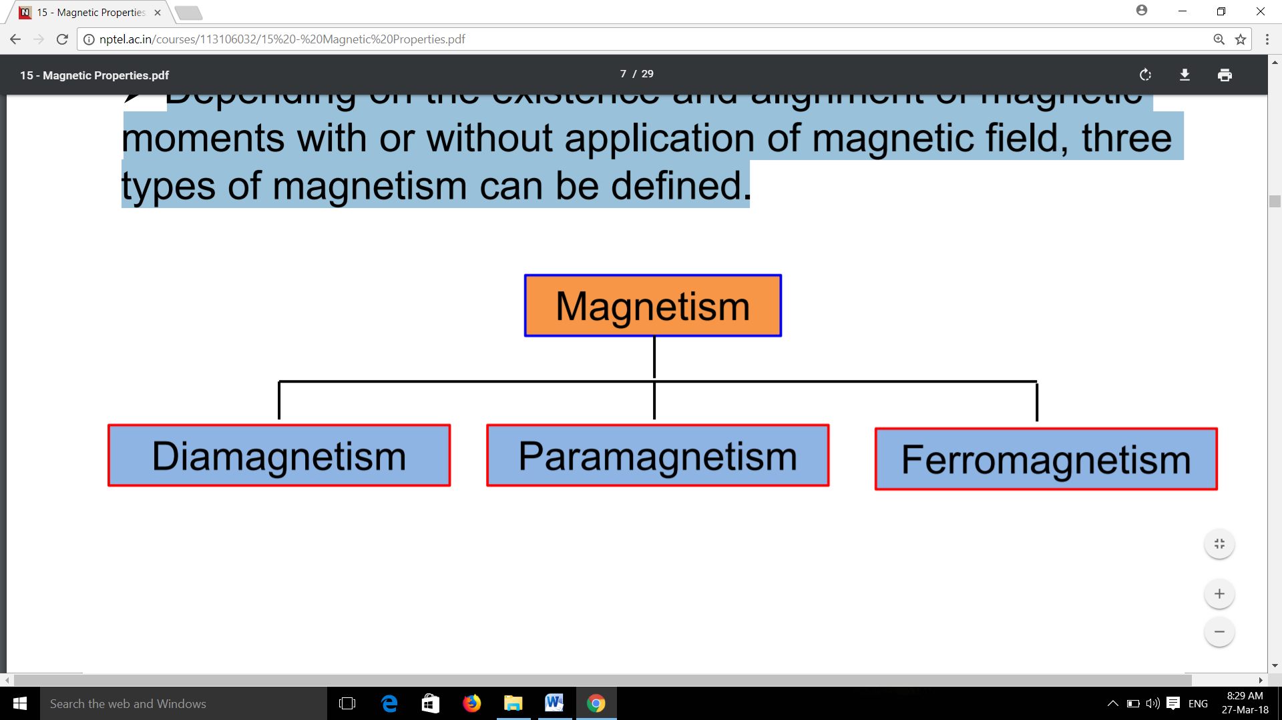

### 5.4.1 Diamagnetism

Diamagnetism is a weak form of magnetism which arises only when an external field is applied.

* It arises due to change in the orbital motion of electrons on application of a magnetic field.
* There is no magnetic dipoles in the absence of a magnetic field and when a magnetic field is applied the dipole moments are aligned opposite to field direction. As shown in figure5.2.
* The magnetic susceptibility, is negative i.e. *B* in a diamagnetic material is less than that of vacuum.

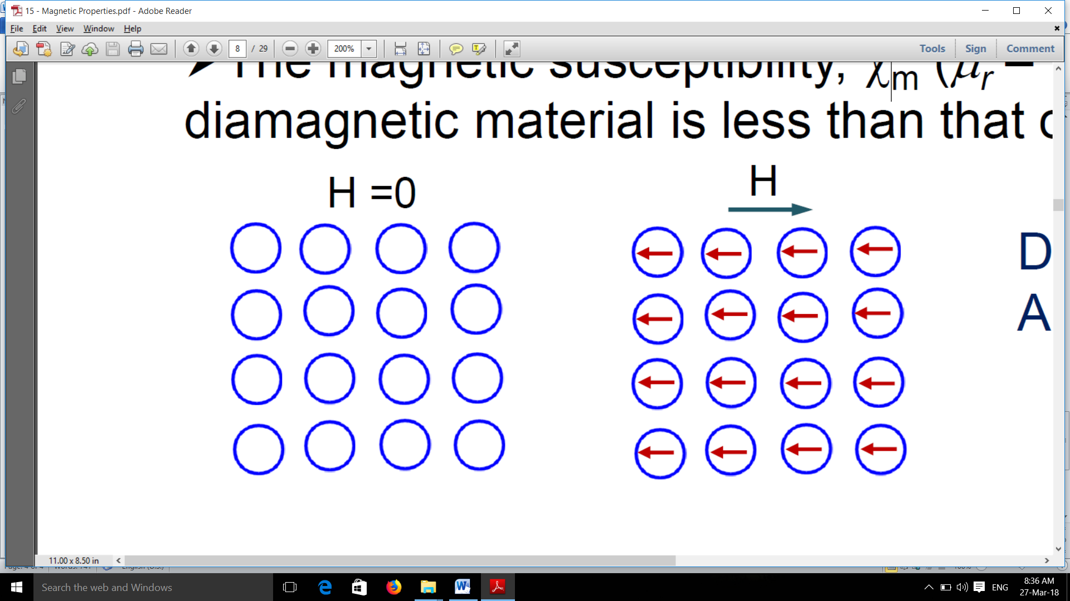

Figure 5.2 Diamagnetism

Diamagnetic materials: Al2O3, Cu, Au, Si, Zn

### 5.4.2 Paramagnetism

In a paramagnetic material the cancellation of magnetic moments between electron pairs is incomplete and hence magnetic moments exist without any external magnetic field.

* However, the magnetic moments are randomly aligned and hence no net magnetization without any external field.
* When a magnetic field is applied all the dipole moments are aligned in the direction of the field as shown in figure 5.3.
* The magnetic susceptibility is small but positive. i.e. B in a paramagnetic material is slightly greater than that of vacuum.

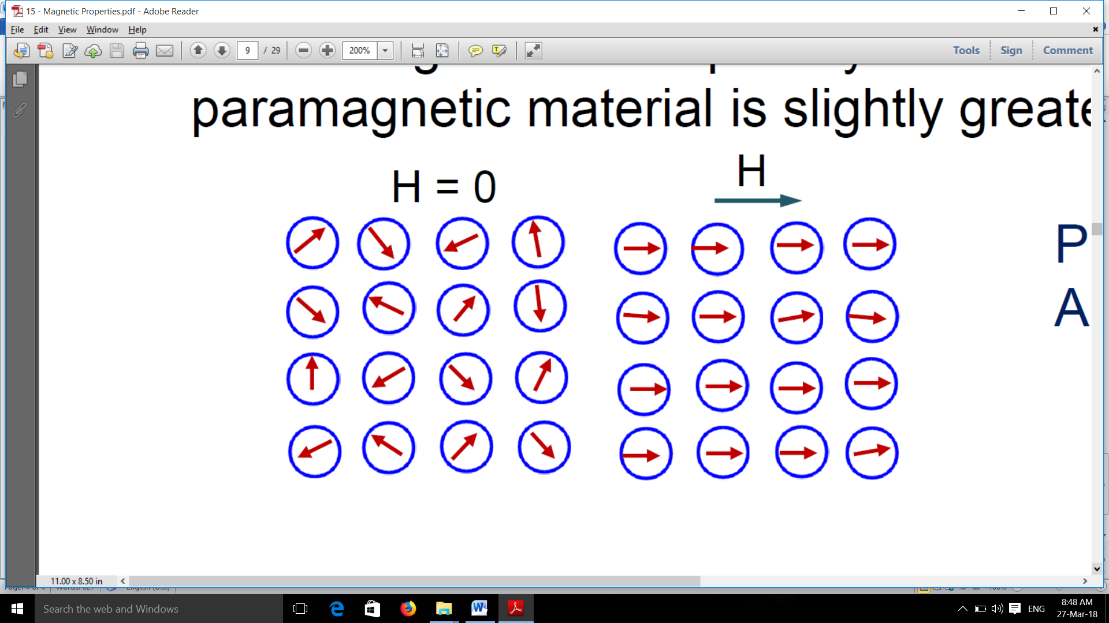

Figure 5.3 Paramagnetism

Paramagnetic materials: Al, Cr, Mo, Ti, Zr.

### 5.4.3 Ferromagnetism

Certain materials possess permanent magnetic moments in the absence of an external magnetic field. This is known as ferromagnetism.

* Permanent magnetic moments in ferromagnetic materials arise due to uncancelled electron spins by virtue of their electron structure.
* The coupling interactions of electron spins of adjacent atoms cause alignment of moments with one another.
* The origin of this coupling is attributed to the electron structure. Ferromagnetic materials like Fe (26 – [Ar] 4s23d6) have incompletely filled d orbitals and hence unpaired electron Spins.

# Chapter 6. Design of Electromagnetic Coil

## 6.1 Coil no. 1

**Assumptions**-

* + The length of coil wire is 30 m, from standard wire gauge conversions our length of wire falls between 28 gauge to 32 gauge, we selected 29 gauge with 0.2859 mm wire diameter. This data is taken from Pyromation inc chart.
  + From magnet diameters 10 and 12 mm, we decided inner diameter of coil as 21 mm and outer diameter of coil as 38 mm. From consideration of total magnet height, we selected length of as 40 mm.
  + The copper fill factor is taken as 0.6 from electromagnetic energy harvesting journal.

**Observation:**

* + Coil inner radius() = 10.5 mm
  + Coil outer radius() = 19 mm
  + Length of coil() = 40 mm
  + Resistance per meter() = 0.5488 Ohm/m
  + Wire diameter() = 0.285 mm
  + Copper fill factor (Kco) =0.6 is taken from chapter no. 2 Electromagnetic Energy Harvesting of Springer Edition.

**Calculations:**

**Step 1-** Calculation of Longitudinal number of turns (Nlong)

**Nlong**

**Step 2-** Calculation of Lateral number of turns (Nlat)

**Nlat**

**Step 3-** Calculation of Total number of turns (N)

**N**

**Step 4-** Calculation of Inductance of coil (Lcoil)

**Lcoil**

**Step 5**- Calculation of Resistance of coil (Rcoil)

**Rcoil**

**Step 6**- Calculation of Parasitic viscous damping factor ()

**Step 7**- Calculation of electromechanical viscous damping factor (

Where, = Total viscous damping factor.

**Result Table**

**Table 2 For calculation of Total number of turns (N) Coil I**

|  |  |  |  |  |  |  |  |
| --- | --- | --- | --- | --- | --- | --- | --- |
| Sr.No. | Inner radius of coil (ri) in mm | Outer radius of coil (ro) in mm | Mean radius of coil  (rm) in mm  rm=(1/2).(ri+ro) | Length of coil (hcoil) in mm | Longitudinal number of turns (Nlong) in turns | Lateral number of turns (Nlat) in turns | Total number of turns (N) in turns  N=Nlong.Nlat |
| 1. | 10.5 | 19 | 14.75 | 40 | 122.6721 | 26.0678 | 3197.7945 |

From the result TABLE NO. 2 we got Total number of turns (N) as **3197.7945 turns**.

**Table 3 For calculation of Inductance and Resistance of coil (Lcoil and Rcoil) Coil I**

|  |  |  |  |  |
| --- | --- | --- | --- | --- |
| Sr.No. | Mean coil radius (rm) in mm | Length of coil (hcoil) in mm | Inductance of coil (Lcoil) in Henry | Resistance of coil (Rcoil) in Ohms |
| 1 | 14.75 | 40 | 0.131325 | 46.86336 |

From the result TABLE NO. 3. We got Inductance of coil (Lcoil)and Resistance of coil (Rcoil ) as **0.131325 Henry** and **46.86336 Ohms**.

## 6.2 Coil no. 2

**Assumptions**-

* + The length of coil wire is 30 m, from standard wire gauge conversions our length of wire falls between 28 gauge to 32 gauge, we selected 29 gauge with 0.2859 mm wire diameter. This data is taken from Pyromation inc. chart.
  + From magnet diameter 10 mm and 12 mm, we decided inner diameter of coil as 30 mm and outer diameter of coil as 45 mm. From consideration of total magnet height, we selected length of as 40 mm.
  + The copper fill factor is taken as 0.6 from electromagnetic energy harvesting journal.

**Observation:**

* + Coil inner radius() = 15 mm
  + Coil outer radius() = 22.5 mm
  + Length of coil() = 35 mm
  + Resistance per meter() = 0.5488 Ohm/m
  + Wire diameter() = 0.285 mm
  + Copper fill factor (Kco) =0.6 is taken from chapter no. 2 Electromagnetic Energy Harvesting of Springer Edition.

**Calculations:**

**Step 1-** Calculation of Longitudinal number of turns (Nlong)

**Step 2-** Calculation of Lateral number of turns (Nlat)

**Step 3-** Calculation of Total number of turns (N)

**Step 4-** Calculation of Inductance of coil (Lcoil)

**Step 5**- Calculation of Resistance of coil (Rcoil)

**Step 6**- Calculation of Parasitic viscous damping factor ()

**Step 7**- Calculation of electromechanical viscous damping factor (

Where, = Total viscous damping factor.

**Result Table**

**Table 4 For calculation of Total number of turns (N) Coil II**

|  |  |  |  |  |  |  |  |
| --- | --- | --- | --- | --- | --- | --- | --- |
| Sr.No. | Inner radius of coil (ri) in mm | Outer radius of coil (ro) in mm | Mean radius of coil  (rm) in mm  rm=(1/2).(ri+ro) | Length of coil (hcoil) in mm | Longitudinal number of turns (Nlong) in turns | Lateral number of turns (Nlat) in turns | Total number of turns (N) in turns  N=Nlong.Nlat |
| 1. | 15 | 22.5 | 18.75 | 35 | 107.3311 | 22.99953 | 2468.565 |

From the result TABLE NO. 4 we got Total number of turns (N) as **2468.565 turns.**

**Table 5 For calculation of Inductance and Resistance of coil (Lcoil and Rcoil) Coil II**

|  |  |  |  |  |
| --- | --- | --- | --- | --- |
| Sr.No. | Mean coil radius (rm) in mm | Length of coil (hcoil) in mm | Inductance of coil (Lcoil) in Henry | Resistance of coil (Rcoil) in Ohms |
| 1 | 18.75 | 35 | 0.134297 | 31.92465 |

From the result TABLE NO. 5 we got Inductance of coil (Lcoil )and Resistance of coil (Rcoil ) as **0.134297 Henry** and **31.92465 Ohms.**

**Experiment I:**

Experiment is done without electromagnetic coil. Only mechanical system is excited.

**Table 6 Observation table for without coil**

|  |  |  |  |  |  |  |  |  |  |
| --- | --- | --- | --- | --- | --- | --- | --- | --- | --- |
| **Sr. No.** | **Speed** | **excitation frequency** | **natural frequency** | **frequency ratio** | **displacement** | **eccentricity** | **magnification Factor** | **relative displacement** | **transmissibility** |
| - | N | ω | ωn | ω/ωn | x | y | x/y | x-y=z | z/y |
| *-* | *rpm* | *rad/sec* | *rad/sec* | *-* | *mm* | *mm* | *-* | *mm* |  |
| 1 |  |  |  |  |  |  |  |  |  |
| 2 |  |  |  |  |  |  |  |  |  |
| 3 |  |  |  |  |  |  |  |  |  |
| 4 |  |  |  |  |  |  |  |  |  |
| 5 |  |  |  |  |  |  |  |  |  |
| **6** |  |  |  |  |  |  |  |  |  |
| 7 |  |  |  |  |  |  |  |  |  |
| 8 |  |  |  |  |  |  |  |  |  |
| 9 |  |  |  |  |  |  |  |  |  |

**Experiment II.**

Coil I with magnet of 10 mm diameter with electromagnetic coil.

**Table 7 Observation table for Coil I and 10 mm Magnet**

|  |  |  |  |  |  |  |  |  |  |
| --- | --- | --- | --- | --- | --- | --- | --- | --- | --- |
| **Sr. No.** | **speed** | **excitation frequency** | **natural frequency** | **frequency ratio** | **displacement** | **eccentricity** | **magnification Factor** | **Relative displacement** | **transmissibility** |
| - | N | ω | ωn | ω/ωn | X | y | x/y | x-y=z | z/y |
| *-* | *rpm* | *rad/sec* | *rad/sec* | *-* | *mm* | *mm* | *-* | *mm* |  |
| 1 |  |  |  |  |  |  |  |  |  |
| 2 |  |  |  |  |  |  |  |  |  |
| 3 |  |  |  |  |  |  |  |  |  |
| 4 |  |  |  |  |  |  |  |  |  |
| 5 |  |  |  |  |  |  |  |  |  |
| **6** |  |  |  |  |  |  |  |  |  |
| 7 |  |  |  |  |  |  |  |  |  |
| 8 |  |  |  |  |  |  |  |  |  |
| 9 |  |  |  |  |  |  |  |  |  |
| 10 |  |  |  |  |  |  |  |  |  |

**Table 8 Observation table for voltage generated**

|  |  |  |  |  |  |  |  |
| --- | --- | --- | --- | --- | --- | --- | --- |
| **Sr. No.** | **speed** | **excitation frequency** | **natural frequency** | **frequency ratio** | **magnification Factor** | **transmissibility** | **Voltage** |
| - | N | ω | ωn | ω/ωn | x/y | z/y | V |
| *-* | *rpm* | *rad/sec* | *rad/sec* | *-* | *-* |  | *mvolt* |
| 1 |  |  |  |  |  |  |  |
| 2 |  |  |  |  |  |  |  |
| 3 |  |  |  |  |  |  |  |
| 4 |  |  |  |  |  |  |  |
| 5 |  |  |  |  |  |  |  |
| **6** |  |  |  |  |  |  |  |
| 7 |  |  |  |  |  |  |  |
| 8 |  |  |  |  |  |  |  |
| 9 |  |  |  |  |  |  |  |
| 10 |  |  |  |  |  |  |  |

# 

# Chapter 9. Conclusion

# Chapter 10. Future Work

1. In future work, the task is to find optimal dimensions of the coupling architecture components (magnet, coil) rather than optimizing damping factors.
2. On the application base (e.g. electrical generator where small amount of vibration occur) one device can be manufactured having electromagnetic system which can generate electricity. Such devices are placed on the surface of generator where more amount of vibrations and maximum displacement is done. By connecting this devices in series or parallel we can vary the voltage and current.
3. The output voltage signals are in AC but applications requires DC. That conversion of power from AC to DC is the next future task.

# Chapter 11. References

**Papers**

1. *D. Spreemann & Y. Manoli*, “Electromagnetic vibration energy harvesting Devices”, Springer series in Advance Microelectronics 35. DOI 10.1007/978-97-007-2944-5_2, 2012.
2. *S. P. Beeby, M. J. Tudor and N. M. White*, “Energy harvesting vibration sources for microsystems applications”, School of Electronics and Computer Science, University of Southampthon, Meas. Sci. technol 17, 2006 175-195.
3. *Garry Berkovic and Ehud Shafir*, “Optical methods for distance and displacement measurements”, Optical sensing group, Advances in Optics and Photonics Volume 4, September 2012, 441- 471.
4. *G. Benet, F. Blanes, J. E. Simo, P. Perez*, “Using infrared sensors for distance measurement in mobile robots”, Robotics an Autonomous system 1006, 2012, 1-12.
5. *Vidyadhar Kamble, Dipesh Makwana, C. Chandramouli*, “Ultrasonic Based Distance Measurement System”, EE616 Electronic design lab project report, EE dept., IIT Bombay, November 2007.
6. *Chang-Woo Song and Seung-Yop Lee*, “Design of a Solenoid Actuator with a Magnetic Plunger for Miniaturized Segment Robots”, “Appl. Sci. 2015, 5, 595-607; doi:10.3390/app5030595”.
7. *Lin Jin, Albert Chee W. Lu, Lai L. Wai, Wei Fan*, “Design Optimization Of Off-Chip Inductors”, “International Electronic Packaging Technical Conference and Exhibition July 6-11, 2003, Maui, Hawaii, USA”.
8. *Chao-Liang Chang , Uei-Ming Jow, Chao-Ta Huang*, “Optimum Design of Inductors used for Wireless Power Transmission Micro-Module”, “2004 ASME International Mechanical Engineering Congress and Exposition November 13-20, 2004, Anaheim, California USA”.

**Books:**

1. S. S. Rao, “Mechanical Vibration”, 5th edition, 45- 273.
2. G. K. Grover, “Mechanical Vibrations”, 8th edition, Nem Chand & Bros.
3. B. L. Theraja, “Electrical technology”, Volume I, S. Chand Publication, 507- 598.
4. V. K. Mehta, Rohit Mehta, “Basic electrical engineering”, S. Chand publication.